PARISH NEWS
The Deverills & Crockerton
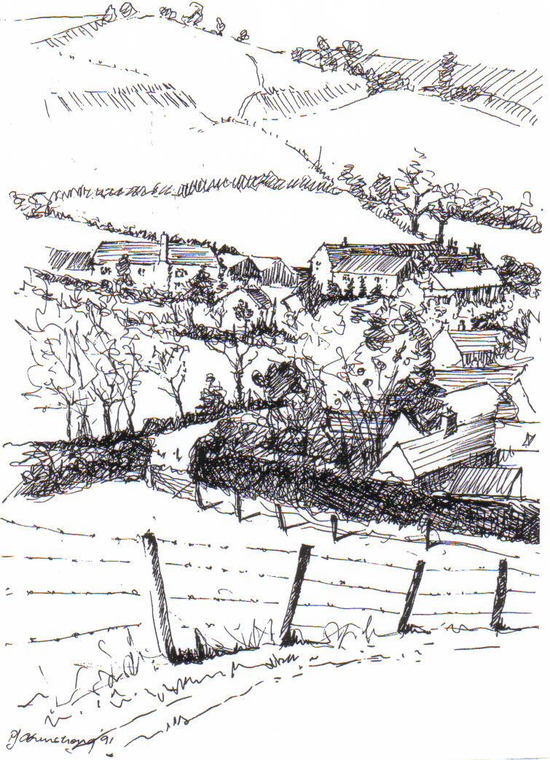

Kingston Deverill from Court Hill
by Pat Armstrong
February 2009

Look inside for local information

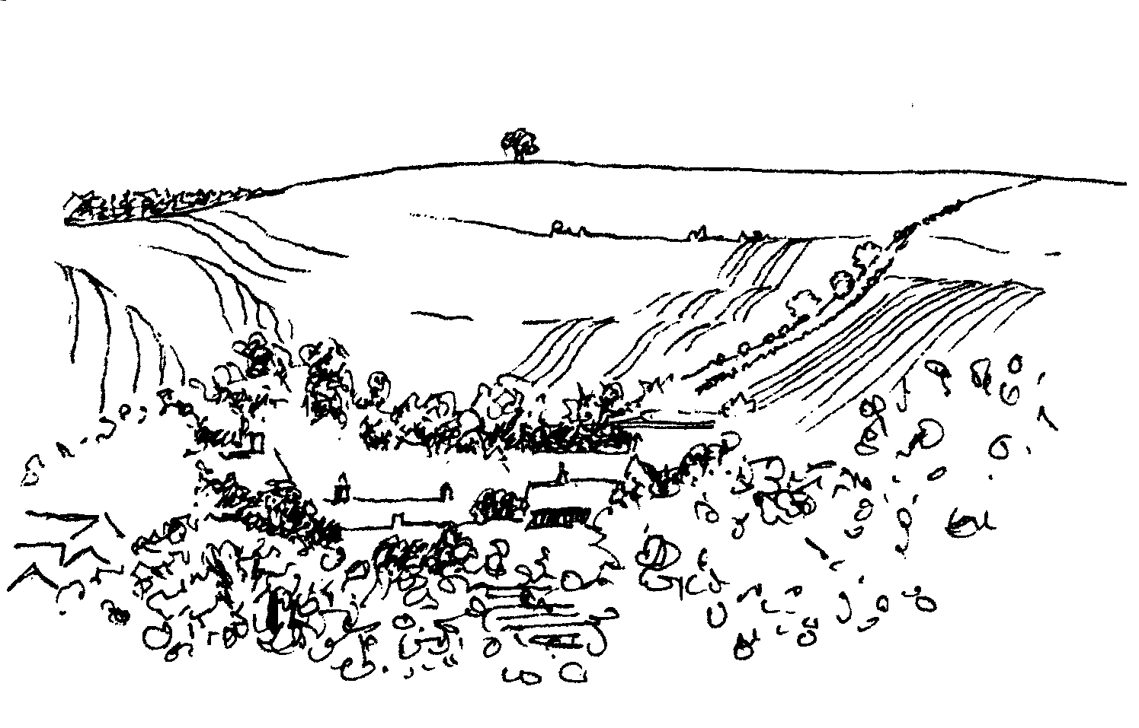

-2-



Coffee, Cards and Chat
Come and enjoy looking at the new range of cards,
ribbons, wrapping paper, and other exciting items
displayed by John and Maddie Goodden
in the Upper Deverills Village Hall on Thursday 19th February
between 10.30 and 12.00 noon - everyone is welcome
Donations will be made to the hall and the churchCoffee, Cards and Chat
Come and enjoy looking at the new range of cards,
ribbons, wrapping paper, and other exciting items
displayed by John and Maddie Goodden
in the Upper Deverills Village Hall on Thursday 19th February
between 10.30 and 12.00 noon - everyone is welcome
Donations will be made to the hall and the church

Coffee, Cards and Chat

Come and enjoy looking at the new range of cards, ribbons, wrapping paper and other exciting items displayed by John and Maddie Goodden in the
Upper Deverills Village Hall on Thursday19th February
between 10:30 and 12:00 noon – everyone is welcome
Donations will be made to the hall and the church

Coffee, Cards and Chat
Come and enjoy looking at the new range of cards,
ribbons, wrapping paper, and other exciting items
displayed by John and Maddie Goodden
in the Upper Deverills Village Hall on Thursday 19th February
between 10.30 and 12.00 noon - everyone is welcome
Donations will be made to the hall and the church

We are Macmillan Cancer Support

AN EVENING WITH TERRY BAKER

WILTSHIRE PLANT EXPERT and CHELSEA MEDALLIST

Friday 27th February 6.30pm for 6.45pm
Sutton Veny Village Hall

Lite Bites Tickets £12.50 Plants For Sale

Please send SAE & cheque (payable to: Macmillan Cancer Support – W11)to Mrs K M Nicklin, Chedlanger House, Warminster, BA12 7RZ

Salisbury Theatre Club Trips
Monday 16th February
The Winslow Boy by Terence Rattigan
Monday 9th March
The Real Thing by Tom Stoppard
Monday 20th April
Restoration by Rose Tremain
Monday 18th May
The Importance of Being Earnest by Oscar Wilde
The cost is £17.00: theatre seat £12.00 and coach trip £5.00
Booking and payment in advance to Mary Stewart Cox Tel 840877
Longmead, Brixton Deverill, Warminster BA12 7EJ
Coach leaves Kingston Church 6.10 pm collects through the Deverills
Performance begins at 7.30 pm

-3-

From your Rector
Firstly, a big ‘thank you’ to all the talented people who decorated our churches for Christmas and Epiphany, they looked lovely and complemented the beautiful buildings during these special seasons.
Secondly, a personal ‘thank you’ for all the get well messages, cards, gifts and kindness I have received while I have been so unwell. I have really appreciated your thoughtfulness and prayers.

With the approach of Lent my attention has been drawn to the Archbishop of Canterbury’s new Lent book for this year, it is on the Eucharist by Timothy Radcliffe called ‘Fully Alive’. The author is a charismatic spiritual leader who speaks to huge audiences around the world. His message is constantly fresh, always a surprise. The Diocese is launching a programme of talks by Timothy called ‘Fully Alive’, the opening address will be in Salisbury Cathedral on 25th February (Ash Wednesday Eucharist) at 5.30 pm. Thereafter he will speak on Wednesdays at 1.00 pm in the Cathedral on 4th, 11th, 18th, and 25th March with a final address on Wednesday 1st April at 7.30 pm. I do recommend this programme of talks and the book to you.
Finally, we will be marking Fairtrade Fortnight this year from 23rd February to 8th March with various events which will be publicised nearer the time, so please look out for further information.
With every blessing to you all
Norma Payne
Annual Revision of Church Electoral Roll
As in previous years the PCC of the Deverills is required to conduct an annual revision of the Church Electoral Roll in the spring. This revision must be completed in time for the Annual Parochial Church Meeting that will take place on Sunday 19th April 2009. Accordingly the period of the revision will be from 1st February until Saturday 28th March and a notice to this effect will be displayed on the notice board in each of our churches in due course.
Please will Parishioners let me know of anyone whose name they think should be removed from the Roll (with a reason please, eg. deceased, moved abroad, etc.), as an aid there is a copy of the current Electoral Roll on the Notice Board of each church. Blank Electoral Roll registration forms will be placed at the back of each church for completion by anyone in the Parish whose name is not on the current Roll but who now wishes to be included. Please send the completed forms to me, or hand them to a Church Warden. Could I also ask that on the forms you include in addition your telephone number and the name by which you wish to be known.

Mike Tulloch - Parish Electoral Roll Officer

-4-
Deverill Valley & Crockerton Women's Institute
Longbridge Deverill Hall - Monday 9th February 7.30 pm
‘Swords & Ploughshares’ - by Romy Wyeth
Followed by a social time - Consequences
For more information contact Ann Dufosee 840360

Longbridge Deverill Village Hall
Pancake evening
Tuesday 24th February 5.00 - 7.00 pm
Tickets £3.00, Children £1.50
Baked potatoes: cheese or baked bean filling and Pancakes!
Please ring Mrs Sylvia Titt on 214825 for tickets
CROCKERTON VILLAGE COMMITTEE
Present the Village Quiz Night
Sunday 8th March at The Bath Arms
7.00 pm for 7.30 pm
£8.50 a ticket to include a main meal
£1 of each ticket kindly donated by Dean to Crockerton School
Please book by 26th February by contacting:
Marion 213739, Tracey 216939, Bernie 218401
Teams of four please – everyone is welcome
Friends of Heytesbury, Knook & Tytherington Churches
2 talks with supper in Sutton Veny village hall in aid of the churches
Tuesday 17th February
First Overland Oxford & Cambridge Far East Expedition 1955
Thursday 19th March
Ancient Treasures and New Inventions
The doors open at 6.30 pm talks to begin at 7.00 pm prompt
Tickets £15.00 for talk & supper, please contact
Jane Howard-Vyse, 74 High Street, Heytesbury BA12 OEB (840258) or
Annie Charlesworth, 57 H Cheques payable to The Friends of HK&T Churches

-5-

Upper Deverills Village Hall
Film Night Friday 6th February - postponement
It is regretted that the Film Night planned for 6th February has been postponed as the necessary licence to show films has not yet been forthcoming.
Indian Curry Night Saturday 18th April
Don’t forget to note this date in your diaries. We will be serving an excellent range of curries and accompaniments, more details in next month’s Parish News.
Upper Deverills Village Hall Kitchen
Some progress has been made regarding the kitchen I am delighted to report. I have received, on behalf of the Village Hall Committee, some good responses to our appeal on which I shall expand in the next issue. As I mentioned before Christmas I would like to see if it is possible to put together a Deverills Cookbook. Would any one who could possibly be interested in supporting this idea like to post me any recipe they would like to see in print, children included. (Clearly I don’t want you to post your children to me.) Good old stand-bys like rice crispy cakes and grannies stew etc. If the response is good I will explore the production costs. Please give a few moments of your time and pop something in the post to help this venture and send it to me at: Longbarrow Cottage, Kingston Deverill, Warminster BA12 7HF. That's all for now folks. Keep our Postie Dave busy with those recipes, thanking you in anticipation.
Dizzy Bridge 845166
Neighbours
Please remember during this cold spell to keep in mind our elderly residents, who may be living on their own, that there is evidence of activity - lights on or off etc.
PC Phil Bridge
Crockerton School - New Mobile classroom update
Planning approval for the replacement of the existing single mobile classroom for a double mobile classroom was granted during December. This means that the school can move forward and appoint the relevant contractors to carry out the works required. The project will start in May and be completed during the summer so that we can take advantage of the new space at the beginning of the new school year in September. We will keep everyone updated as more details become available.
Graham Dopheide
Save the Children Fund
The Christmas Bazaar held at Mill Farm House, Hill Deverill last November raised £1,800.00 for the charity, a good result from a happy event where there were some lovely stalls. Thank you to Val Dale and family for their hospitality and to everyone who contributes and supports us. Sadly, the total of £986.68 made from the sale of newspaper over the past twelve months for Save the Children was down, this was due to a decrease in tonnage not payment. So if you don’t already contribute please consider doing so. The paper skip in Longbridge Deverill is still up and running so please continue to bring your paper; newspapers, magazines and paper backs are all acceptable but no string, cardboard, plastic or yellow pages please.
Anne Hurd

-6-
Upper Deverill Parish Council
Broadband Working Party
There are some unsatisfactory issues concerning the broadband service for the Upper Deverills. The Parish Council Broadband Working Party mentioned previously in this magazine, has now met and formulated a plan of action and they would greatly value your cooperation in this matter. The aim of the Working Party is to seek to improve broadband in our area. To do this we must first establish the scope and size of the problem hence a questionnaire is being designed to help achieve this. This will arrive at your home with this Parish News. Please complete and return it within 10 days whether or not you presently have broadband. Once we have analysed the survey responses we shall publish a summary of the findings in the Parish News and also on the Deverills & Crockerton web site www.deverills.org.uk.
Meanwhile, for those of you using broadband you can check the speed BT forecast you should receive versus your actual download/upload speed. To see BT’s forecast type www.tinyurl.com/deverills into your browser and then type your telephone number into the box. You will receive an immediate forecast of the maximum speed for that line. Do not enter your post code as this appears less accurate. This is also a helpful test if you do not have broadband and are considering it. To see the speed you actually receive, type www.tinyurl.com/deverills-test into your browser. This takes you to an ‘independent’ website ThinkBroadband.com. Highlight the start button and wait. To see the results you need to confirm that your ISP is the one predicted by highlighting the blue bar at the bottom saying, “I live in the UK and my ISP is selected above”. You do not need to complete the details on post code and phone number unless you wish to register. Registration does give access to useful information on how factors like distance, time of day and the state of wiring in your house affects broadband. To obtain a representative actual speed it is best to do this test several times on different days and times and calculate an average. Please make a note of the BT forecast speed and your actual speed results, as you will need these to complete our questionnaire. We look forward to receiving them.
Albert Lee 844759
Change of Use Permission for Agricultural Land
Have you purchased agricultural land in recent years and intend to or have incorporated it into your garden? If so, you may not be aware you need to apply for planning permission for change of use. Any agricultural land incorporated into a domestic garden and used, for example, for growing vegetables, flowers, shrubs, trees, etc, requires a change of use application; but if that land is used perhaps as a pony paddock or keeping a couple of sheep then it would be regarded as agricultural and no change of use application would be required. All enquiries and applications should be made to the Planning Department at West Wiltshire District Council.
Felicity Wheeler

-7-

Traffic Issue Update
White Lines – Monkton Deverill
Residents in Monkton Deverill have expressed concern over the number of ‘near misses’ that have occurred at the bend in the centre of the village, and as a result have requested that hazard centre white lines be placed on the bend. By the time you read this newsletter the lines should be in place.
Proposed Weight Restriction
You may be aware that Wiltshire County Council (WCC) has adopted a Freight Route Network Scheme to inform Heavy Goods Vehicle (HGV) drivers of the most appropriate routes to use in Wiltshire. The network is still being developed and an assessment tool called Large Vehicles in Rural Areas (LVIRA) is being used to progress the plan. The plan affects the residents of both the Upper Deverills and Longbridge and Crockerton Parishes because it proposes that a 7.5t weight restriction is placed on the B3095 (Longbridge Deverill to Mere road), the Longbridge Deverill to Maiden Bradley road, the Kingston Deverill to Maiden Bradley road and the Hindon Road which leads from Monkton Deverill to the A350.
WCC will be sending out details of the proposed Freight Route Network Scheme for comment at the beginning of February. The plan will be published in local papers, placed on notices on affected routes and sent to Parish Councils. It is important that if you have a view you write to WCC directly (contact details will be given on the plan), or conversely you can pass your views onto your local Parish Councillors. WCC has given interested parties 21 days in which to comment on the scheme.
This is an important issue because if the scheme is approved there is likely to be a reduction in the number of HGVs using the above roads, particularly the B3095. On the other hand there may be some who believe that HGV drivers should have the flexibility to choose which routes they wish. Indeed there is a very powerful freight lobby who will undoubtedly be robustly opposing the imposition of any weight restrictions.
Closure of the A303 for Repair
The Highways Agency (HA) has now decided to delay the closure of the A303 because of the number of adverse comments it received concerning its closure plan. Nevertheless, the Upper Deverills Parish Council (UDPC) will be writing to the HA expressing their concern that when the A303 is closed/restricted for repair, the B3095 (and potentially the Hindon Road) will be used as unofficial diversion routes. This is because they are by far the shortest routes around the Chaddenwick Hill to Willoughby Hedge repair section. In addition, the HA’s original closure plan only offered a temporary 7.5t weight limit for the B3095 as ‘protection’ against overuse as a unofficial diversion route. The UDPC believe that this is not enough and are strongly recommending to the HA that instead they consider a series of graduated protection measures for the B3095, that would be triggered depending on the size of traffic flow through the valley.
Ranald Blue 841374

-8-
SERVICES PARISH OF DEVERILLS & HORNINGSHAM

Sunday Presentation of Christ
1st February Kingston 8.00 am Holy Communion 1662
Longbridge 10.30 am Morning Worship
Horningsham 5.30 pm Evensong

Sunday 3rd before Lent
8th February Kingston 10.30 am Holy Communion
Horningsham 11.15 am Holy Communion

Sunday 2nd before Lent
15th February Longbridge 8.00 am Holy Communion 1662
Brixton 10.30 am Holy Communion

Sunday 1st before Lent
22nd February Longbridge 10.30 am Holy Communion
Horningsham 11.15 am Morning Prayer
Brixton 6.00 pm Evening Prayer

Wednesday Ash Wednesday
25th February Longbridge 10.15 am Ash Wednesday Service

Sunday 1st of Lent
1st March Brixton 8.00 am Holy Communion 1662
Longbridge 10.30 am Holy Communion
Horningsham 5.30 pm Evensong

Tuesday, Wednesday, Thursday, Friday
Longbridge 8.30 am Morning Prayer
Wednesday
Longbridge 10.15 am Holy Communion

Longbridge Deverill Church Flowers
The ladies who keep our church looking so good all though the year deserve a huge thank you from us all. I have been especially grateful for the co-operation I have had over the years, and hope some kind person will volunteer to take over the rota. I am very happy to give any help and advice if needed.
Daphne Woodcock
-9-

SERVICES PARISH OF CORSLEY & CHAPMANSLADE

Sunday Presentation of Christ
1st February Corsley 9.00 am Holy Communion

Sunday 3rd before Lent
8th February Chapmanslade 9.00 am Holy Communion
Temple 11.00 am Morning Prayer

Sunday 2nd before Lent
15th February Chapmanslade 9.00 am Holy Communion
Corsley 6.00 pm Evening Worship

Sunday 1st before Lent
22nd February Temple 9.00 am Holy Communion 1662
Corsley 10.30 am Parish Service

Tuesday Shrove Tuesday Celebration -Talents Project
24th February Corsley 7.00 pm Pancake Party

Wednesday Ash Wednesday
25th February Chapmanslade 7.00 pm Ash Wednesday Service

Sunday 1st of Lent
1st March Corsley 9.00 am Holy Communion
Ivy House St Denys Retreat Centre
A place for rest, refreshment and renewal
Friday 13th February - CSD Gathering Day
A quiet day of guided reflection open to all
Cost: £16.00 including coffee, lunch and tea
For more information please phone 214824
Ivy House St Denys Retreat Centre
A place for rest, refreshment and renewal
Friday 13th February - CSD Gathering Day
A quiet day of guided reflection open to all
Cost: £16.00 including coffee, lunch and tea
For more information please phone 214824
Ivy House St Denys Retreat Centre
A place for rest, refreshment and renewal
Friday 13th February - CSD Gathering Day
A quiet day of guided reflection open to all
Cost: £16.00 including coffee, lunch and tea
For more information please phone 214824

Sir James Thynne House, Longbridge Deverill

A self-contained ground floor flat is available in this charming old building:

bed/sitting room, small kitchen, easy-access shower, use of garden area

Applicants should be aged 50 years or over and resident locally

For further information please contact Sue Jackson on 840322

-10-

Your Parish News - Donations and Subscriptions
Thank you to those who have already generously handed in their subscriptions this year, if you have not please may I remind you how much we rely on your financial support to keep our production costs down. A pale blue envelope was included in the January edition of the Parish News but if you need another one please do not hesitate to contact me and I will get one to you. The envelopes can be:
Put into the collection at Church or given to a Church Warden
Given or sent to David Stratton, PCC Treasurer, Manor Farm, Kingston Deverill
Put into the collecting box on the counter at Longbridge Post Office
Given or sent to Judy Munro, Whitepits Lodge, Kingston Deverill BA12 7HD.
Judy Munro - Editor - 844385

Church Cleaners for February
Kingston - Mrs Stratton & Mrs Mounde
Brixton - Mrs Armstrong & Mrs Burridge
Longbridge - Monday 2nd February 9.30 - 10.30 am - all helpers
Church Flower Arrangers for February
 | Kingston | Brixton | Longbridge
1st Feb | Mrs Mounde | Mrs Greenwood | Mrs Moberly
8th Feb | Mrs Mounde | Mrs Greenwood | Mrs Moberly
15th Feb | Mrs McCulloch | Mrs Sutton | Mrs Plaistow
22nd Feb | Mrs McCulloch | Mrs Sutton | Mrs Plaistow

CONTACT THE EDITOR AND WEBSITE
Parish News Editor - Judy Munro 844385
Contributions for the Parish News through my letterbox or
by post to Whitepits Lodge, Kingston Deverill, Warminster,
BA12 7HD or by Email: judymunro@tiscali.co.uk Thank you
Please remember the deadline is the 15th of every month

Website: www.deverills.org.uk Email address:info@deverills.org.uk
Website manager : Kate Wilkinson 844998
Contents: Parish News with church services, Parish Register, Events, Local News plus pictures and other information
Contact the Clergy
Please contact Norma Payne (841321) or Di Britten (01373 832515) if anyone is housebound and would like communion or a visit at home; or if someone is ill and needs our prayers; or to discuss any church matter.
Office administrator phone 210149 or email: office@cleyhill-team.org.uk

-11-
Rainfall 2008
The rainfall records for the catchment area around the parish reveals that the annual amount for 2008, taken from five different sites, averaged 42.58 inches. This is 2 inches more than last year and the wettest year since 2002. The usual difference between the west of the parish and the east is slightly more this year:
Kingston recorded 48.57 inches Longbridge recorded 39.31 inches
The wettest months were January and July, both of these months yielded over 5 inches of rain. The driest months were February, June and, would you believe it for some at the east end of the parish, December.
On 13th December in the north west corner of the parish one of our weather watches recorded 2.2 inches in 2 hours. At the same time in Longbridge we measured 1.3 inches. This very heavy rain obviously provided the cause of the flooding, which started at Kingston, where a number of houses were flooded at about 10.00 am. The flood continued down the valley to cause serous flooding in Brixton, and finally quite a scare in Hill and Longbridge Deverills at about 5.00 pm. Prior to 13th December there had been a period of hard frost. The torrential rain falling on frozen ground created conditions for a faster run off than usual. However, we have endured heavier rain in the past without flooding occurring, we should treat this as a warning. This flooding should be a reminder to our two Parish Councils, the Environment Agency, and Wiltshire Council, which replaces West Wiltshire District Council on 1st April this year, to keep an eye on the state of the River Wylye within the parish, including the hatches and riverbanks.
John Robins - Manor Farm, Longbridge Deverill
Book Review - In Search of Fatima by Ghada Karmi
Anyone who wants to know more about the Palestinians and how the present situation affects them should read this book, it affected me greatly. It tells of the author’s early life in Palestine Jerusalem with her family; as she grows up great changes take place altering her life and that of her family. Eventually, the family come together again in London. She goes to a primary school and becomes fully integrated and feels English. The rest of the family find it hard to adapt. As an adult she trains to be a doctor, it is only then she finds people do not see her as English. She determines to return to her homeland and I suspect she may be working as a doctor in Gaza now. If the conflict there disturbs you this may help you understand one side of the story.
This Christmas I was given a book by a Palestinian lawyer named Raja Shehaden called ‘Palestinian Walks - Notes on a Vanishing Landscape’. It is perhaps a little hard to imagine hundreds of small houses being built on the hills above Brixton Deverill with no means of stopping their erection, but I picture this as I read the book and remember the wild scenery in the Holy Land and what is happening there. I am glad we visited it 15 years ago, but even then it was obvious who had the best land.
I am very grateful to my family and friends for the books they give me!
Elisabeth Atkinson
If you would like to review a book for the Parish News please contact the Editor.

-12-

Where have you been?
The White Lion Inn, Bourton, Dorset (01747 840866) www.whitelionbourton.co.uk
We heard that the White Lion had been revamped some time ago and had thought about giving it a try for a while. We have passed by on our way to Wincanton many times but never had the time to call in. However on Friday, 9th January we went to Wincanton mid-morning and decided to call at the White Lion for lunch on the way back. We are so glad that we did!
It was a cold January day but the pub was lovely and warm inside with fires or wood burning stoves blazing in the three main rooms. The owners have managed to revitalise the decor without destroying the feeling of it being a village pub or losing any of its charm. In fact they have added to it by painting the walls in the sort of colours you get in a heritage range of paint, such as a light sage green, which shows off the architecture and also by displaying old artefacts on shelves and ledges.
The menu changes daily, although some dishes will remain constant, like the absolutely delicious steak and kidney pie – made to the same recipe as that used by previous owners. And that typifies the very sensible approach the current owners seem to have taken; they have kept what is good and changed what needed to be changed. The main meals are reasonably priced, for example: beer battered haddock and chips with winter leaf £8.95; Gloucester Old Spot sausages with chive mash and red onion marmalade £8.95; steak and kidney pie, peas and chips £9.95. There are also more adventurous dishes such as sea bass with white wine, vanilla and garlic cream and crushed basil potatoes for £10.50. The dessert menu is excellent - my husband told me that the chocolate fondant pudding, cooked to order, was so delicious he could have licked the plate (not on my watch he couldn’t!). A reasonably priced children’s menu is also available.
Dogs are allowed in the bar. The best seats for daytime eating are probably in the bay window of the small dining room on the left as you enter the pub but all the rooms are pleasant. At the rear is a rather lovely mature garden which must be delightful for summer dining. The staff are knowledgeable and good humoured and very obliging about making small adjustments to dishes to cater for dietary requirements. My view is that the White Lion is a little gem. Give it a try.
If you have chocolate fanatic for a partner, their Valentine’s Night menu has a strong chocolate theme at £28.50 for three courses plus coffee and truffles. It would be worth booking.
The usual plea for your recommendations, please send them to me at: farthings.kd@btinternet.com or by phone (844291) or through my door at Farthings, Kingston Deverill.
Trish Shuler

-13-
Nature Notes
As the temperatures dropped so the food consumption went up and up! I don’t think I can ever remember when the bird feeders have been so busy. I put out extra fat balls and suet as well as mealworms and soaked currants and tried to keep some fresh water available for them. Some days this froze so quickly that it became an impossible task. One day, when we had the hoar frost, I saw a chaffinch ‘drinking’ the frost. It certainly looked very pretty but I do hope we don’t get temperatures quite that low again this winter, although I know it is still possible as we have the rest of January and all of February to get through yet. The birds always amaze me how they can cope with such extreme cold. I realise that eating more will help to maintain their body temperature and that they trap air in between the feathers for insulation which is like us wearing several layers of clothes. They need to bathe to keep their feathers in tip top condition for insulation which is why I was so keen to provide fresh water for them. I often saw a bird having a bath during that very cold snap, made me shiver just to watch them! Some birds will huddle together to keep warm. Wrens in particular do this and I saw lots of wrens going into the house martin nests along the front of the house at dusk. There must have been 20 or so, they were coming from all directions of the garden and that was only the ones I saw, I didn’t hang about too long to watch in the cold! I hadn’t realised how many wrens we had about; mind you, I have no idea how far some of them were travelling. It could very well have been that word had got around and wrens from the hedgerows and fields were joining our local garden population.
Today we finally got around to cleaning out the bird boxes dotted about the garden and buildings. Out of the 15 we cleaned only 4 were used last year. I think that reflects the weather we had! One nest still had some eggs in it; I think the parents probably abandoned the nest due to the awful weather. One box we had to discard as it was rotten and past repairing and another had been attacked badly around the entrance hole probably by a woodpecker. Most of the boxes we have got are equipped with metal nest box plates that screw directly over the hole to prevent squirrels, woodpeckers and other predators from enlarging the hole and getting to the young birds inside. Obviously we had missed this one but we managed to salvage the metal nest box plate from the discarded box and put it around the attacked hole so we still had one good safe box out of the two. So next year we will only have 14 boxes to clean! It’s not too late to put up boxes if you want to. In fact National Nest Box week is normally the second week in February.
Spring is just around the corner. The bulbs are poking through and I have heard robins, blackbirds and song thrushes singing in the mornings. It won’t be long before others join them. I have also spotted more hares, 3 the other evening, the most I have seen for ages. Their numbers will increase in the next few months and soon we will be watching them boxing again.
Jane Trollope (written on 14th January)

-14-

LOCAL COUNCILS, SOCIETIES, GROUPS etc.
Longbridge and Crockerton Parish Council
Karen Manfield 215526 (Chair) Peter Whithey 840347 (Vice Chair)
Helen Few 840119 (Clerk) Thomas Minter 216909
Bill Hurd 840023 Elaine Pidgeon 212878
Julian Algar 840816 Graham Read 840296
Brian Marshall 214789
Upper Deverills Parish Council
Lady Felicity Wheeler 844683 (Chair) Ranald Blue 841374
Jacqueline Smith 840238 (Clerk) Patricia Shuler 844291
Sarah Fagan 844123 Robin Greenwood 840743
District Councillor
Shear Water Ward - Michael Mounde 844363

Longbridge Deverill Village Hall Committee
Jo Nelson 840784 (Chair)
Barbara Smith 840251 (Secretary) Sylvia Titt 214825 (Caretaker)

Upper Deverills Village Hall
Richard Cousens 844970 (Chair)
Mandy Martyn 844320 (Secretary) John Lea 844325 (Hall bookings)

Crockerton Millennium Committee
Marion Thomas 213739 (Chair)

Pre-School Children and Parents ‘Thursday Group’
Barbara Beilby 844995 (Chair) Sylvia Titt 214825 (Leader)

Deverill Valley & Crockerton W I
Ruth Sutton (President) Jill Russell 840209 (Secretary)

Sir James Thynne Almshouse
Mrs Sue Jackson 840322 (Steward)

Deverills Cricket Club
Jamie Fagan 844123 Peter Child 01963 34593

Wylye Valley Tennis Club
Colin Singer 213696

Wylye Valley Flower Club
Mrs Hazel Yate 215617 (President) Mrs S Scott 213689 (Programme Secretary)

Wiltshire Wildlife Trust
Elm Tree Court, Long Street, Devizes SN10 1NJ www.wiltshirewildlife.org

Rural Community Beat Officer - Police Community Support Officer
PC Phil Bridge - PCSO Ian Owen - 0845 408 7000

Hospital Transport Link Scheme 211655

-15-

F O R T H C O M I N G E V E N T S
Forthcoming Events

F O R T H C O M I N G E V E N T S
- Hearing Loss Lip-reading Wednesdays Margaret Head (213259)
- Scottish Dancing Monday Evenings Aline Fry (841054)
- Badminton Mondays & Fridays 3.00 - 5.00 pm Alison Rymell (844819)
- Pre-school & Parents Group Thursdays 10.00 - 11.30 am See p14
- Women’s Institute ‘Swords to Ploughshares’ Monday 9th February See p4
- Wylye Valley Flower Club ‘By the River’ Tuesday 10th February See p14
- Ivy House Quiet Day Friday 13th February See p9
- Salisbury Theatre Club Monday 16th February See p2
- Sutton Veny Village Hall Talk Tuesday 17th February See p4
- Coffee Cards & Chat Thursday 19th February See p2
- Fairtrade Fortnight 23rd February to 8th March See p3
- Pancake Evening Tuesday 24th February See p4
- Fully Alive talks begin Wednesday 25th February See p3
- Terry Baker Evening Friday 27th February See p2
- Longbridge & Crockerton Parish Council meeting 7.30 pm Monday 2nd March at Longbridge Village Hall See 14
- Crockerton Quiz Night Sunday 8th March See p4
- Salisbury Theatre Club Monday 9th March See p2
- Upper Deverills Parish Council meeting 7.30 pm
Wednesday 11th March Upper Deverills Village Hall See p14
- Sutton Veny Village Hall Talk Thursday 19th March See p24
- Indian Curry Night Saturday 18th April See p5
- Salisbury Theatre Club Monday 20th April See p2
- Salisbury Theatre Club Monday 18th May See p2
16-

PARISH OF THE DEVERILLS
Churches
SS Peter & Paul the Apostles Longbridge Deverill (LD)
St Michael the Archangel Brixton Deverill (BD)
St Mary the Virgin Kingston Deverill KD)
St John the Baptist Horningsham (H)
Rector
Rev Norma Payne, 6 Homefields, Longbridge Deverill 841321
Clergy
Rev Diana Britten, 69 Lane End, Corsley 01373 832515
Licensed Lay Ministers
Mr John Budgen, Woodlands, Sutton End, Crockerton 218203
Col Robin Chappell, 7 Elm Hill, Warminster 212153
Churchwardens
Mrs Elisabeth Atkinson, 133 Foxholes, Crockerton (LD) 212129
Mr Nigel Poole, 7 Homefields, Longbridge Deverill (LD) 840902
Mrs Mary Stewart Cox, Longmead, Brixton Deverill (BD) 840877
Major Mike Tulloch, Spring Cottage, Monkton Deverill (KD) 844381
Mr Tim Moore, Manor House, Church Lane, Horningsham (H) 844336
Lay Pastoral Assistant Co-ordinator
Rev Norma Payne, 6 Homefields, Longbridge Deverill 84l321
PCC Treasurer
Mr David Stratton, Manor Farm, Kingston Deverill 844549
PCC Secretary
Mrs Anne Honley, Dry Hill House, Crockerton 215956
Church Electoral Roll Officer
Major Mike Tulloch, Spring Cottage, Monkton Deverill 844381
Parish News Editor
Mrs Judy Munro, Whitepits Lodge, Kingston Deverill 844385
Organist
Mr John Budgen, Woodlands, Sutton End, Crockerton 218203
Tower Captain
Mr Stephen Young, 68 Highbury Park, Warminster 212796
Caretaker - Longbridge Church
Mrs Sylvia Titt, 7 Church Street, Longbridge Deverill 214825
Office Administrator (Mon-Fri 10.00 - 12.00)
Mr Dick Collins, 22 Church Street, Warminster 210149

